Static keyword:

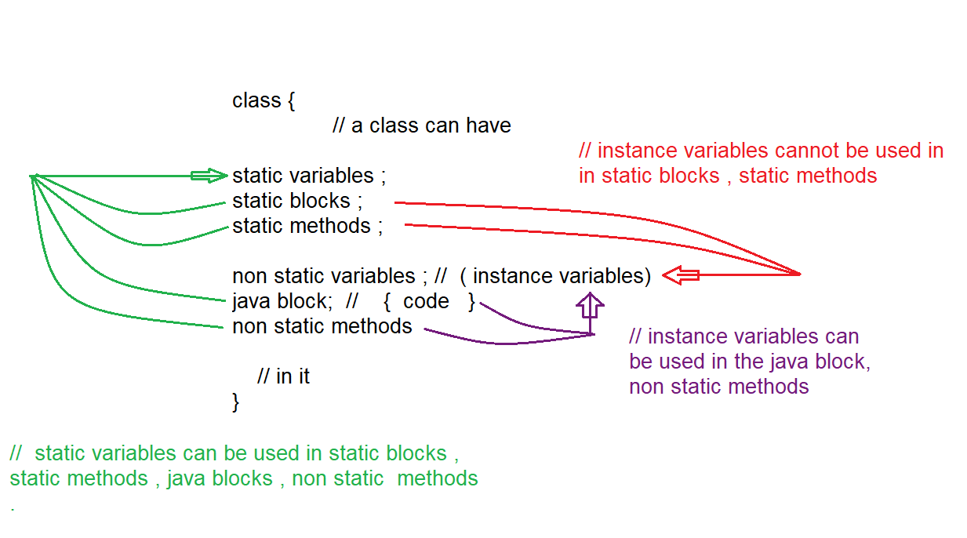

Note: main() is not the first one to execute in the program , jvm will decide whether to execute the program or not , if program has main() it is executed .

Order of execution of java program

1. Static variable
2. Static block
3. Static method (main method is also static)
4. Non static variables
5. non static block
6. constructor
7. non static method

jvm evaluates the program in the above order.

but you can invoke them in main() in different order of your choice .

Eg: Order_Of_Execution

Note: when object is created 3 things will happen

1. memory for instance variables is allocated
2. java block is executed
3. constructor is executed.

Note: static block will have no name.

Syntax: static {

// Code

}

Program is executed as follows:

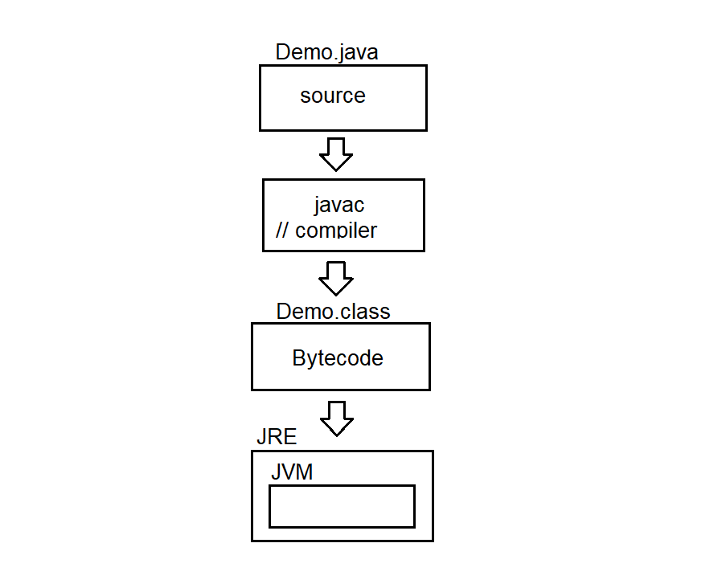

JRE (java runtime environment) internally has JVM (java virtual machine)

Byte code is given to JRE

JRE gives the byte code to the JVM

JVM takes that bytecode, and process it internally

Note: static variables and static blocks are executed during class loading, main method is executed by jvm by default

Note: if static method and main method is in same class you can call static method directly with method_name , class_name.method_name , with obj_ref.method_name also

Eg: Static_Methods

If static method and main method is in different class you should call static method with class_name.method, obj_ref.method_name (here object reference should be of class type in which static method is present)

Eg: Static_Method_1

Static variables, static block , static method ( only main method ) is executed automatically

Eg: Automatic_Execution

// go through the code

Static method (user defined), constructor, normal method is not executed automatically, it is executed if and only if we call them.

Eg: Manual_Execution

// go through the code

Note: we can call method inside a method, but cannot create new method inside a method.

Note: non static variables (instance variables) cannot be used in static block and static method, because memory for instance variables is allocated only when object is created.

But static blocks, and static methods are executed (at class loading) even before memory of instance variables is allocated. so instance variables are not allowed in static blocks and static methods.

Note: you can use static variables in all the static blocks, static methods, java block, constructor, non-static method. since their memory is allocated at first (during class loading itself)

Need of static

Eg: Count_No_Of_Objects

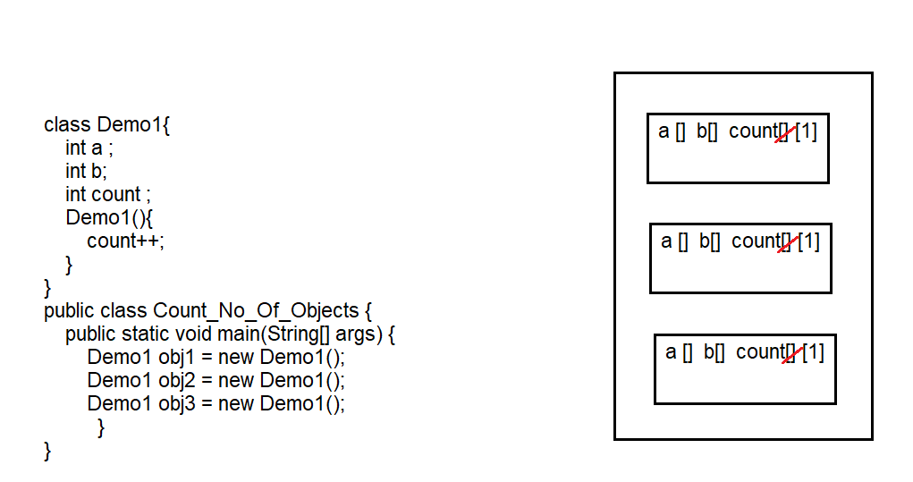

Here count is instance variable, memory is allocated every time the object is created. so cannot calculate the objects. the possible way is to make count as static. then memory is allocated once and can be incremented every time when object is created.

Eg: Count_No_Of_Objects_Using_Static_Variable_In_Constructor

// here static variable count is written in constructor, if the variable is not declared as static every time a new object is declared and default value is assigned to it.

Note: which ever content is common in all the constructors include that in the non-static block.

If it is kept in a static block it is executed only once. but java block will be executed no of times whenever object is created.

Eg: Count_No_Of_Objects_Using_Non_Static_Block

Static variables memory is created once and can be used multiple times.

Non static block is executed even before constructor’s body. .this() (or) super() should be the first one to be executed in constructor actual body . but even before that java block is executed first as a constructor body and then actual constructor body is executed.

Eg: java_block_Execution

Static variable:

1. static keyword is used
2. executed during class loading
3. Static variables in Java are stored in a special area of memory called the "Method Area" or "Class Area".
4. one copy is used by all the objects
5. can be called using class name.
6. also called as class variables
7. object independent
8. can be used in static elements and non-static elements

Note:

1. if something needs to be executed even before main method and during class loading, write them in static block, generally we use to initialize static variables.

Eg: Static_Block_Execution

1. if something need to be executed during object creation write them in constructor (or) non static block. And if there is some common statements in all the constructors write them in java block.

Eg: Static_Method

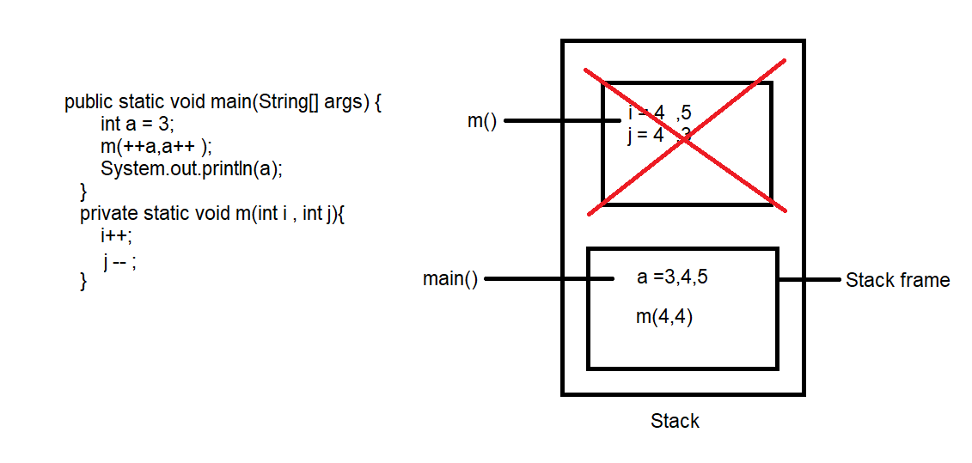

Here first main method is brought to stack frame and executed, method m() is called in main method, so another stack frame will be created for method m(), after the execution of method m(), it is removed from stack area, and local variables i,j has scope only until its execution completes. so a value is fetched from main method which is 5.

Note: Pass by value: whenever you pass the data w.r.t variable, those changes will not be reflected in the memory (example above program there we passed values to method and there are not reflected in the memory)

Pass by reference:

Eg: Fizz

Pass by reference is not supported in java directly as it promotes pointers concept, but we can use it indirectly.

here you are passing object references, whatever changes are made they are stored in the object and reflected in main method.

Java Pass By Reference And Pass By Value

There are basically two types of techniques for passing the parameters in Java. The first one is pass-by-value and the second one is pass-by-reference. One thing to remember here is that when a [primitive typ](https://www.softwaretestinghelp.com/java/java-data-types-loops-arrays-switch-assertions/)e is passed to a method, then it is done by the use of pass-by-value.

However, all the non-primitive types that include objects of any class are always implicitly passed by use of pass-by-reference.

Basically, pass-by-value means that the actual value of the variable is passed and pass-by-reference means the memory location is passed where the value of the variable is stored.

### Ways To Create A Pass-by-Reference

Java supports pass-by-value,0 but there are three different ways to create a pass-by-reference in Java.

* Make the member variable public inside a class.
* Return a value from a method and update the same inside the class.
* Create a single element array and pass it as a parameter to the method.

### Making The Member Variable Public

In this technique, the object of a class is passed to the add() method and it updates the public member variable ‘a’. You can see that the original memory address where the value is stored has been changed.

Eg: Make_Member_Variable_Public

### Returning A Value From A Method

In this technique, we are trying to return a value from add() method as we have changed the type from “void” to “int”. The changes or addition in the value is returned by the add() method and the original memory address has been updated.

Eg: Returning_Value_From_Method

### Creating A Single Element Array & Passing As A Parameter

In this technique, we have created a single element array and passed it as a parameter to the method add(int a[]). You can see that the original memory address is changed in this case as well.

Eg: Creating_Element_Array_Passing_Prarameter

Note: whenever a common copy of data has to be accessed by all the objects then make that data member as static.

If the data is object specific then make that data member as instance variable.

Eg: Farmer_Loan

// here rate of interest is common to all the objects (farmers) so it is made static

// principal amount, time period (object specific) is different for every farmer so used instance varaibles

Note: static methods are also known as generic methods since they are not object dependent.

Instance methods are also known as specific methods since they are object specific (object dependent).

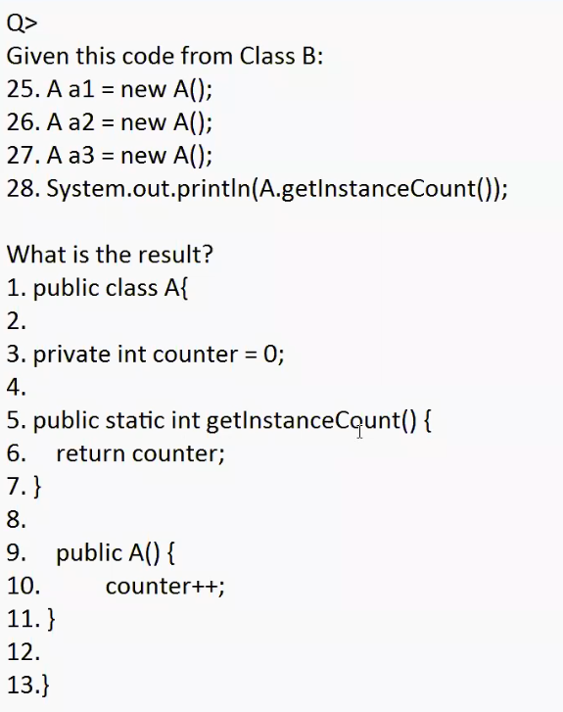

Ans: Instance variable counter can’t be accessed in the static method getInstanceCount(), which leads to compilation error.

Eg: Static_Method_Eg2

// go through the code

Eg: Gamma

// go through the code

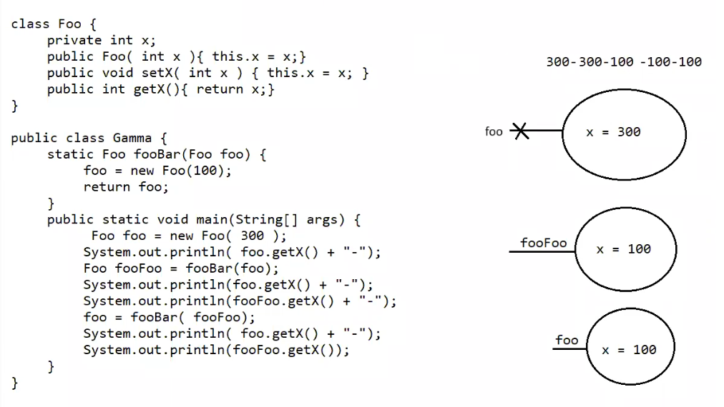

Eg: Static_Block_Eg5

